Judicial Reverse Mentoring Application Form and Mentor Guidance

This information and guidance have been prepared for those applying to undertake the role of a “Reverse Mentor” as part of the Judicial Reverse Mentoring Scheme.

Any Judge who you will be working with on the scheme has specifically asked to work with a reverse mentor. Therefore, they will be starting from a point of interest and curiosity about what your experiences as a solicitor or a barrister from a underrepresented in the judiciary and they want to learn more about the reality and the challenges you face as a legal practitioner which may be very different form the ones they faced.

Your willingness to be open about your experiences and those in the legal profession and where relevant, your thoughts about working in the courts and with the judiciary will be critical to the judge gaining a better understanding of the realities faced by underrepresented groups in the legal profession today. There will be a clear mutual understanding about confidentiality and its importance. It is hoped that you will feel free and able to share personal experiences in the knowledge that they will not be shared further or without your consent and vice versa. It is also hoped that the judge will feel comfortable and able to ask you any questions they might have.

The scheme is built up of six one-to-one Mentor/Mentee sessions, agreed mutually by you both, to be completed by the end of the programme. See session scope and design:
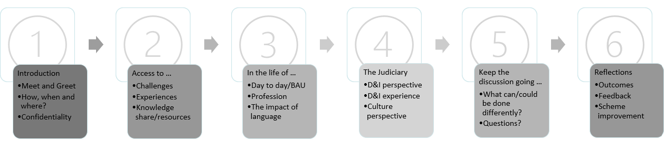
There will be support provided throughout the scheme via session resources and materials and mentor support sessions held by a Lead. The Leadership, Development and Talent team who manage the scheme are also available to provide ad hoc support and arrange one-to-one support if beneficial. There are also events in which you will be invited to attend both at the beginning and close of the scheme.

What will be expected from you:

- To be conscientious in your approach to the arrangement (e.g., to keep to agreed meeting times and to treat anything discussed in confidence); and to have the six sessions by the end of the programme.
- To aim to increase the judge’s understanding of the experience of underrepresented group(s) in the legal profession and to share your experiences and perceptions honestly and openly.
- To deal tactfully and respectfully with any issues that are raised.
- To be open minded about what you can learn from the experience and engage with reflection at the end of the process.

At any point during the scheme should you wish to withdraw as a mentor, it will be helpful if you can advise us well in advance so we can find a suitable mentor for your judge (mentee).
If during the period of your reverse mentoring, you have any queries or issues please contact JudicialLeadership@judiciary.uk.

The Judicial Reverse Mentoring Scheme: Application Form

Please complete and provide information as required below which will be used to match you with a mentee. To support the process in which the pairing can be done expeditiously please return this application form as soon as possible, the application date has been extended till Monday 13th May 2024 at 12pm.

Your personal details will be treated in the strictest confidence, however, to aid the matching process please note that information supplied may be shared with your potential Mentee. The information provided will also be used to aid analysis and evaluation of the scheme.

Part A: About you
Surname
Forename
Title
Professional Background | Are you a Barrister or Solicitor? | Month and year of qualification:
Current contact details | Telephone Number: | Email address:

Please select/describe as appropriate:
Sex | Male/Female/Other  If other, please specify:
 | Are you a member of the LGBTQ+ community?  If yes, and content to, please could you advise regarding your representation in the community? This will assist in ensuring we make a suitable match.  Please advise here: | Y/N
 | Do you have a disability?  If yes, can you give a broad indication of your disability? For example, mobility, sight impaired, hearing, non-visible disabilities/health condition etc.  Please advise here: | Y/N
Ethnicity | Asian or Asian British
 | Black/African/Caribbean or Black British
 | White
 | Mixed/multiple ethnic backgrounds
Other

Please specify if other:

 | If helpful we would like to provide the opportunity to elaborate on your ethnic identity. If there is any additional information beyond what is provided above, please elaborate here:
Social Mobility* | Attended a (non-fee paying) state school or college.  Was the first generation in your family to attend university.  What was the occupation of your main household earner when you were aged 14?  - professional background – modern professional and traditional occupation; senior or junior manager or administrator  - intermediate background – clerical and intermediate occupation; small business owner  - working class background – technical and craft occupation; long-term unemployed; routine, semi-routine manual and service occupation
 | If there is any additional information which could support the matching exercise, in relation to your social mobility, please elaborate here:
*Social mobility refers to change in a person's socio-economic situation, either in relation to their parents (inter-generational mobility) or throughout their lifetime (intra-generational mobility).

Career History
Please give details below, maximum of 150 words of your career history (including current role) in the areas of law of which you have built expertise through professional experience.

Part B: Additional Information
Please fill in the below sections to support your application.
1. | Please explain here why you are interested becoming a Mentor on the Judicial Reverse Mentoring Scheme?
2. | We will match you with a mentor from a pool of Judges. Are there any considerations about how you are matched of which we can try to take into consideration?
3. | Are there any courts that you appear at regularly? We will try to avoid pairing you with a judge from those courts, but this cannot be guaranteed.

A As a pre-requisite to participating in the scheme, you will need to have knowledge that:

- You should hold ten years or less post qualification legal experience.

- You will need to be able to communicate for the duration of the scheme and set aside time for mentoring your designated judge.

- Surrounding the Judicial Reverse Scheme there will be Mentor supporting sessions and events which your attendance will be requested.

Is there any reason why you feel you may not be able to commit to the requirements of the scheme or any aspect as set out, which you feel is a concern based on your own personal situation? (We ask this to help us ascertain whether there is anything we can do to support your application, whether that is additional support or the match in which we make to enable you to partake in this cohort.)

Please disclose here:

Part C: Data Privacy Notice and Declaration

DATA PRIVACY
The personal information you provide will be used to match you with a Reverse Mentor. It will be kept on a secure network and will only be accessed by the Leadership Development and Talent Team within the Judicial Office. Information provided will be retained for 12 months after the end of your mentoring (unless otherwise agreed with you), so that the scheme can be evaluated. If you no longer wish to be available to the scheme your personal data will be deleted. You can find more information about how judicial HR processes personal data here:
Data Privacy Notices - Courts and Tribunals Judiciary

JUDICIAL REVERSE MENTORING SCHEME MENTOR DECLARATION
If matched:

I confirm my willingness to retain confidentiality of information disclosed to me during any Mentoring discussions unless in exceptional circumstances such as concern, complaint and in the situation of consensual provision by the other party, this could be in relation to an element/s of information.

Please tick to confirm that you have read, understand and agree on the Privacy Notice and Declaration.
Once complete, please email this form to JudicialLeadership@judiciary.uk.

