July 2024 | ISLEWORTH  NEWS |  |  |  |  |  |  |  | Issue 1
PTPH and other non-trial hearings – From 29th July 2024  We have been struggling to get all PTPHs and other non-trial hearings listed as well as the trials so FROM 29th July 2024 we will aim to list all PTPHs (other than PVL) in a single court (with overflow elsewhere as needed).  From then prosecutors at PTPHs with in person defendants are expected also to be in person in accordance with LCJ guidance. CPS HAVE COMMITTED to ensure that there are at least two prosecutors presenting the cases in person to allow effective engagement with the defence.  Since these will be bail cases, or in person custody cases, the defence advocates will be also need to be in person (as now).  The cases will be listed in broad time blocks rather than individually to allow for advice and negotiation.  As a general rule, and subject to capacity, prisoners will be produced in person at PTPH if:  • An interpreter is required;  • It is a case with more than 3 defendants in custody.  If the defendant is by PVL then both defence and prosecutor may appear remotely.  We continue to be flexible about CVP attendance at bail or appropriate sentence hearing by prosecutors |  |  |  | 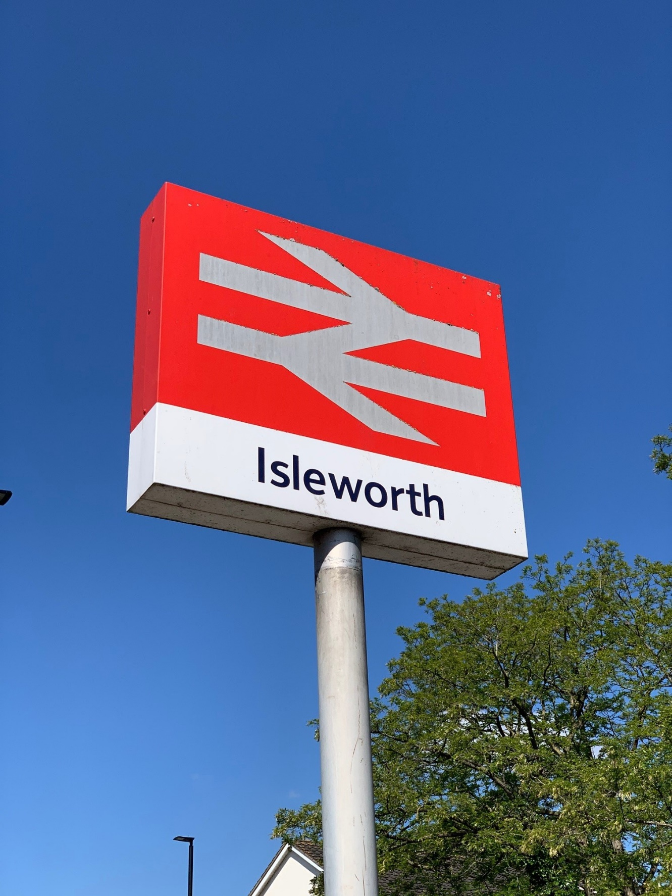
Scrubs Prisoners to get headphones for PVL to Harrow and Isleworth
From 15th July 2024
 |  |  |  | Sound on the PVL from Wormwood Scrubs can be a real problem because of feedback and external noise at the prison.  Pending the provision of the new dedicated suite HHJ Lodge (Harrow) and HHJ Edmunds KC (Isleworth) have agreed to a 3 month trial whereby the prisoner linked to the Crown Court at Harrow or Isleworth will be provided with headphones the better to hear proceedings.  This is to address background noise. The prison team have an obligation to sort out technical issues  This is a temporary expedient to assist sound quality for prisoner and the court and not a permanent change. It has proved a help in Bristol and Durham. |  |  |  | This should also help with interpreters but for court hearings involving interpreters the courts may well continue to require personal attendance.  Prisoners will not be forced to wear headphones if they decline.  Headphones will only be used when there is one defendant (ie not multi defendant cases).  If you encounter problems or have comments please send them to:  Official Prison Video Transition Lead - kelly.nethercoat@justice.gov.uk  Or by email to the ops managersHarrow harriet.yorke2@justice.gov.uk  Isleworth Harpreet.dale@justice.gov.uk or Stephen.stone@justice.gpv.uk

Reduce Non-Trial hearings |  |  | Apply CrimPR 3.7  . |  |  |  | Section 28  The latest updates
We are trying to reduce the number of non-trial hearings sought by one side or other, often unilaterally, and trust the parties to engage.  When parties attend a non-trial hearing without adequate instructions the court will resist just listing another hearing. |  |  | Do use CrimPR 3.7 to agree variations of timetable that don’t affect a hearing date. When doing so make sure subsequent dates are adjusted too. Don’t forget to inform the court that you have agreed a new timetable under CrimPR3.7  [And put a note on DCS please] |  |  |  | Applications for s.28 pre-recorded cross-examination will not be considered unless the ABE interview transcript (not just a summary) has been served. This is in accordance with CrimPD and because it is pointless setting a s.28 timetable when we don’t know when the transcript will arrive.

