# Judicial Reverse Mentoring 2025 –Application Information for Mentors

## Introduction and Overview

The Judicial Reverse Mentoring scheme was developed with the central purpose to foster greater understanding among the judiciary of the experience of individual lawyers from underrepresented groups, and of the specific barriers faced by these groups in accessing a career in law and in the judiciary. ​

Reverse mentoring challenges the idea of mentoring being hierarchical by turning the traditional mentoring format on its head, with the senior leader being mentored by a younger or more junior employee. This process recognises that there are opportunities to learn on both sides of a mentoring relationship, with significant benefit for both parties. Some reverse mentoring schemes, including this one, focus on sharing the experience of individuals in/from underrepresented groups. This supports one of the core objectives of the Judicial Diversity and Inclusion Strategy: “supporting and building a more inclusive and respectful culture and working environment within the judiciary”. [Click here to read more about the strategy.](https://www.judiciary.uk/about-the-judiciary/diversity/diversity-strategy-2020-25/)

The scheme is focused on six mentoring sessions between a judge (Mentee) and legal professional (Mentor), to be arranged in your pairing. These are preceded by a launch event, supported by facilitated support sessions and the provision of resources and guidance materials, then finally concluded with a closing event to celebrate completion of the programme. The Diversity and Inclusion team, who manage the scheme, are also available to provide ad hoc support at any time during the scheme. See below for an overview of the scheme:

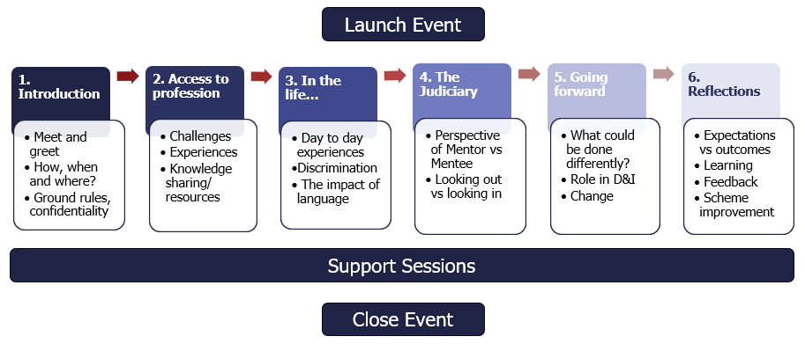

We endeavour to match pairings so that the Mentor is unlikely to appear at the Mentee’s court or before the Mentee. However, it is not possible to guarantee this.

## About **you**

The Mentor role on this scheme is open to currently practising Legal Professionals from underrepresented backgrounds who are in their first 10 years post qualification/call. This includes: individuals of Black, Asian and ethnic minority backgrounds, women, individuals with disabilities, members of the LGBTQ+ community and those from socio-economically disadvantaged backgrounds.

The scheme is aimed at those who would like to take part in making a positive impact on the judiciary by fostering a greater understanding of the experience of those from underrepresented groups in accessing a career in law and in the judiciary. The scheme also enables you the opportunity to gain a greater understanding of the judiciary.

You will be expected to:

* Be conscientious in your approach to the arrangement, keep to agreed meeting times as far as possible, and commit to completing the six sessions by the end of the programme.
* Take the lead in discussions to support your mentee’s understanding of the experience of underrepresented group(s) in the legal profession.
* Share your experiences and perceptions honestly and openly, treating anything discussed in confidence (your mentee will be expected to do the same).
* Deal tactfully and respectfully with any issues that are raised.
* Be open minded about what you can learn from the experience and engage with reflection at the end of the process.

## Testimonials

Hear first-hand about the experiences of Mentor and Mentee pairs from the 2024 cohort:

[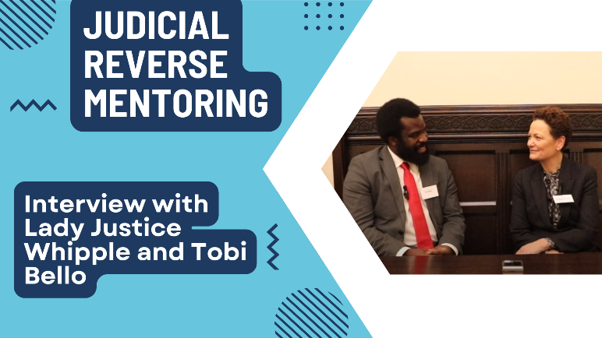](https://www.youtube.com/watch?v=HvEbWYNqIGs) [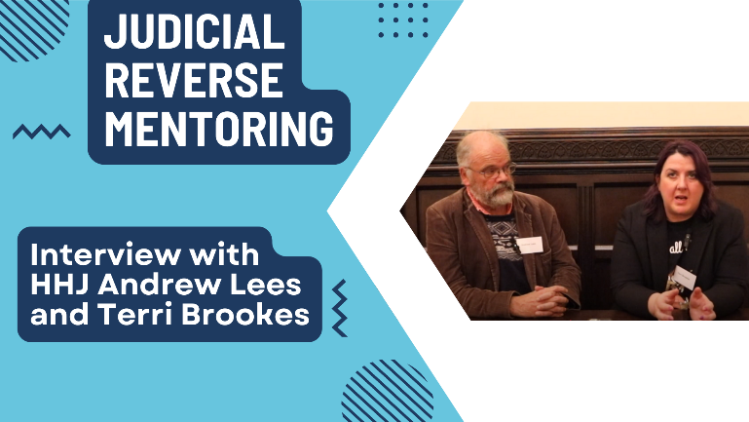](https://www.youtube.com/watch?v=k85wduQ8m0Y)

[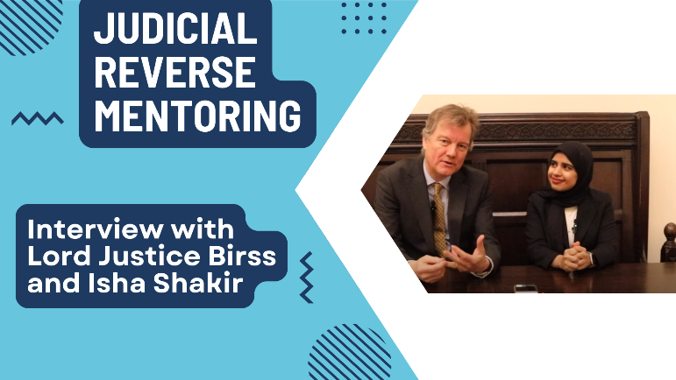](https://www.youtube.com/watch?v=SYMEar4wrpM) [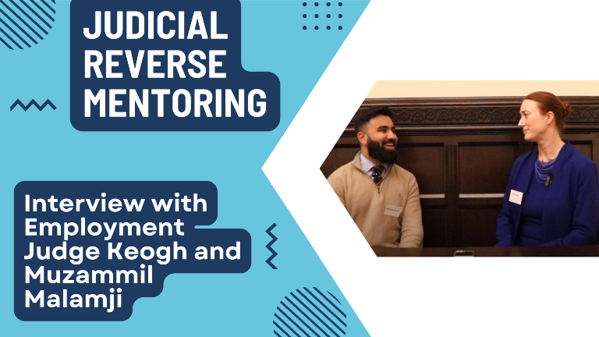](https://www.youtube.com/watch?v=jGtD15_2qjU)

[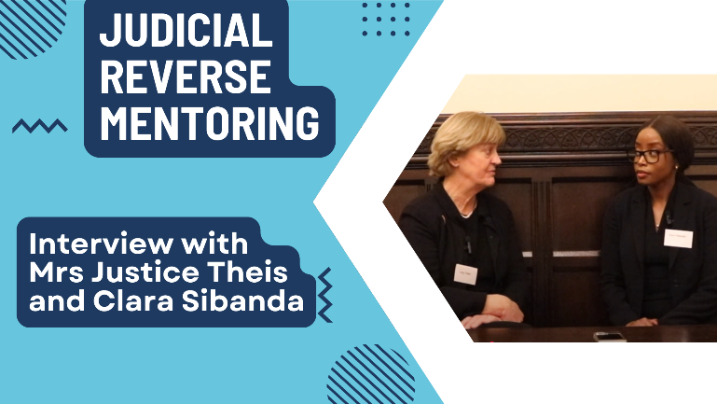](https://www.youtube.com/watch?v=UIUEEBd7QG4)

## Application

If you are interested in applying to be a Mentor for the 2025 cohort of the Judicial Reverse Mentoring scheme, please complete and submit [this application form via MS Forms](https://forms.office.com/e/s6KDz78tvX).

The deadline for applications is **5pm on Friday 28 March 2025**, after which the MS Forms will be closed.

If you have any queries, concerns or issues, please contact [diversity@judiciary.uk](mailto:diversity@judiciary.uk)

Following submission of an application, should you wish to withdraw as a mentor, please inform the Diversity and Inclusion Team on the email above at the earliest possible.